Is Ecuador home to the world's best chocolate?
By Irene Caselli
BBC online June 11, 2013
http://www.bbc.co.uk/news/world-latin-america-22733002

Esmeraldas province, Ecuador
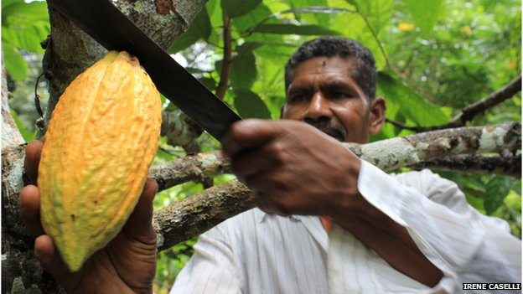

In the lush province of Esmeraldas, on Ecuador's northern border with Colombia, farmers are proud to say they produce "black gold." They are not talking about oil, Ecuador's main export, but cocoa beans. The smooth, bitter-tasting paste extracted from the beans is the key ingredient in chocolate and one of this Andean country's claims to fame. It is also deeply connected to the history of Ecuador, the world's largest exporter of cocoa until the beginning of the 20th Century.
Plant disease and the rise of new cultivations in British and French colonies across Africa and Asia saw Ecuador lose its top spot in the early 1900s. Cocoa started losing its appeal to farmers and was replaced by bananas and coffee, which were more lucrative. West Africa became the world's leader in cocoa production and exports, with a focus on so-called "bulk" or "ordinary" beans. These are used for processed chocolate-flavored candies and sweets. "Fine" or "flavor" beans, the top-quality varieties used in gourmet products because of their superior taste, account for only 5% of the world's cocoa production, but demand for them is increasing.

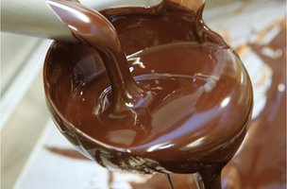
Connoisseurs say fine chocolate has as many distinctive tastes as fine wine.

Much like wine, chocolate reflects the flavors of the region where cocoa beans are grown, and how they are dried and fermented. Over the last decade, as the demand for more flavorful cocoa rose, Ecuador emerged as the pre-eminent exporter of fine beans. It is a favorite destination for globetrotting chocolatiers in search of the best, and cocoa production has also become a sustainable source of income for Ecuador's farmers. "Farmers didn't use to pay much attention to cocoa," says Ignacio Estupinan, a 66-year-old farmer who is known in the area as Don Nacho. "Now everybody knows how valuable cocoa is. It's the best business we have," he adds.
Scholars believe cocoa plants first grew in the Amazon basin, possibly in the area that now corresponds to Venezuela, another large cocoa exporter. However, a recent archaeological study suggests that Ecuador may have been the original home of the cocoa bean. Archaeologist Francisco Valdez found ceramic pottery dating to 3,300 BC that contained microscopic remnants of cocoa. The discovery, made in Ecuador's southern Amazonian region of Zamora Chinchipe, suggests that cocoa beans were being harvested and consumed more than 5,000 years ago.
The West's love affair with chocolate started much later -- in the 16th Century -- when Aztec ruler Montezuma introduced Spanish conquistador Hernan Cortes to a spicy chocolate drink, known as "xocolatl." When sugar was added to the mix, the drink became a fad in Europe, and cocoa much sought after. Unlike other Spanish colonies in South America, where gold and silver were abundant, Ecuador was exploited for its cocoa.

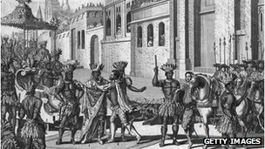
A scene depicting Spanish explorer Hernan Cortez meeting Montezuma, king of the Aztecs.

Ecuador's native cocoa beans are known as "Nacional" or "Arriba", a name believed to derive from the location of its discovery. Arriba means "up river" and many cocoa plantations were located along the Guayas River, which flows towards the port of Guayaquil, Ecuador's largest city.
In her book Chocolate Unwrapped, Sarah Jane Evans, one of the UK's leading food writers and a founding member of the Academy of Chocolate, says that the characteristic of Ecuador's fine cocoa is "a floral profile with blackcurrants and spice." Chocolate tasters say the aroma of Ecuador's cacao is more complex because Arriba beans vary hugely in taste and size according to the area in which they are grown. "Each bean has a special, different flavor," says Santiago Peralta, founder of Pacari, a successful Ecuadorean brand of fine organic chocolate. Mr. Peralta says the quality of Ecuador's chocolate is due to the country's diversity in terrain and equatorial location on the equator. While Ecuadorean chocolate is known for its floral characteristics, some beans taste more like fruits, while others have a nutty flavor. "We tailor-make our chocolate according to the cocoa beans we receive," Mr. Peralta says, adding that he tastes every new batch of beans that arrives.
Mr. Peralta's dedication is one of the reasons Pacari has become the success story of Ecuador's cocoa boom. "We wanted to have the best quality -- it was the only chance we had to make it," he explains. "After 250 years exporting cocoa, nobody knew how to make chocolate in this country." In 2002, together with his wife, Carla Barboto, Mr. Peralta went looking for old cocoa trees, while developing a fair-trade model to give farmers better pay for a better product.
The experiment worked. His chocolate company won several prizes at the 2012 International Chocolate Awards for its combination of flavors and a successful alternative business model. One of its bars, Raw Chocolate, was judged the best "dark plain" bar in the world.
Pacari's Ecuador-based production did not go unnoticed. Other Ecuadorean companies started making their own chocolate and foreign chocolate-makers came to Ecuador not only to source their beans, but also to produce bars. New York-based Red Thalhammer visited several cocoa-producing countries before settling for Ecuador. A native of Austria, Ms. Thalhammer had previously worked on branding for gourmet food and was not ready to let go of those high standards for her own chocolate. "Ecuador has super-high quality cocoa," Ms. Thalhammer says.
She started her own chocolate line, called Antidote Choco, made entirely in Ecuador.
Several other chocolate-makers have followed suit. One company, Ecuatoriana de Chocolates, opened up a factory in 2007 to help chocolatiers go from bean to bar in one location. The implications go far. For example, in Esmeraldas, one of the poorest provinces in the country, farmers can now get more money if they produce high quality cocoa. "In the past, Esmeraldas was not considered a cocoa-growing area, but now it has been producing prize-winning chocolate," says Daysi Rodriguez, a community worker in Esmeraldas. "This fills us with pride!"
On his farm, Don Nacho looks at a 50-year-old cocoa tree. He works on his own on the 60-hectare farm, where he grows 30 different varieties of fruit, besides cocoa. He seems tired, but he also seems to care about something else, more important. "We have to work together to make our country look good abroad," he says. Ecuador's new black gold may be providing a rather stable future for farmers, while at the same time putting Ecuador back on the chocolate map.

From cocoa bean to chocolate bar
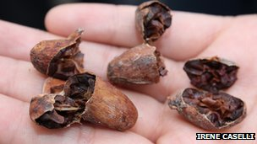

- It takes six months for cocoa beans to ripen. Harvests take place twice a year
- The beans, which are covered in a white pulp, are removed from the pods
- Beans are put in large heaps and covered up to ferment. This takes about a week. and is when the cocoa flavour starts to develop
- Beans are then dried for a week then taken to the chocolate factory
- They are then roasted, and separated from their shells in hulling machines
- The insides of the bean, called nibs, are turned into a liquid or chocolate liquor
- The chocolate liquor is blended with cocoa butter, and other ingredients and stirred for several hours
- The resulting thick mixture comes out and is poured into bar-shaped containers
- The bars are now ready to be packaged and eaten, about four days after the cocoa beans reached the factory

